CLASS XII

Supplementary Reading Material in Economics

**Part A : Introductory Microeconomics**

**(Effective for March 2015 Examination)**

**CENTRAL BOARD OF SECONDARY EDUCATION Preet Vihar, Delhi - 110092**

**INTRODUCTORY MICROECONOMICS**

**UNIT - I**

**PRODUCTION POSSIBILITIES CURVE**

The production possibilities (PP) curve is a graphical medium of highlighting the central problem of 'what to produce'. To decide what to produce and in what quantities, it is first necessary to know what is obtainable. The PP curve shows the options that are obtainable, or simply the production possibilities.

What is obtainable is based on the following **assumptions:**

1. The resources available are fixed.
2. The technology remains unchanged.
3. The resources are fully employed.
4. The resources are efficiently employed.
5. The resources are not equally efficient in production of all products. Thus if resources are transferred from production of one good to another, the cost increases. In other words marginal opportunity cost increases.

The last assumption needs explanation because it determines the shape of the PP curve. If this assumption changes, the shape changes.

Efficiency in production means productivity i.e. output per unit of an input. Let the input be worker. Suppose an economy produces only two goods X and Y. Suppose a worker is employed in production of X because he is best suited for it. The economy decides to reduce production of X and increase that of Y. The worker is transferred to Y. He is not that efficient in production of Y as he was in X. His productivity in Y will be low, and so cost of production high.

The implication is clear. If the resources are transferred from one use to another, the less and less efficient resources will be transferred leading to rise in the **marginal opportunity cost** which is technically termed as **marginal rate of transformation** (MRT). What is MRT?

**Marginal Rate of Transformation (MRT)**

To simplify, let us assume that only two goods are produced in an economy. Let these two goods be guns and butter, the famous example given by Samuelson. The guns symbolize defense goods and butter, the civilian goods. The example, therefore, symbolizes the problem of choice between civilian goods and war goods. In fact it is a problem of choice before all the countries of the world.

Suppose if all the resources are engaged in the production of guns, there will be a maximum number of guns that can be produced per year. Let it be 15 units (one unit may be taken as equal to 1000, or one lakh and so on). At the other extreme suppose all the resources are employed in production of butter only. Let the maximum quantity of butter that can be produced is 5 units. These are the two extreme possibilities. In between there are others if the resources are partly used for the production of guns and partly for production of butter. Given the extremes and the in-between possibilities, a schedule can be prepared. It can be called a production possibilities schedule. Let the schedule be:

1

**Production Possibilities Schedule**

|  |  |  |  |  |  |  |  |
| --- | --- | --- | --- | --- | --- | --- | --- |
| Possibilities | Guns | Butter | MRT = |  | Guns |  |  |
|  | Butter | |  |
|  | (units) | (units) |  |  |  |
| A | 15 | 0 |  | - | |  |  |
| B | 14 | 1 | 1G : IB | | | |  |
| C | 12 | 2 | 2G : IB | | | |  |
| D | 9 | 3 | 3G : IB | | | |  |
| E | 5 | 4 | 4G : IB | | | |  |
| F | 0 | 5 | 5G : IB | | | |  |
|  |  |  |  |  |  |  |  |

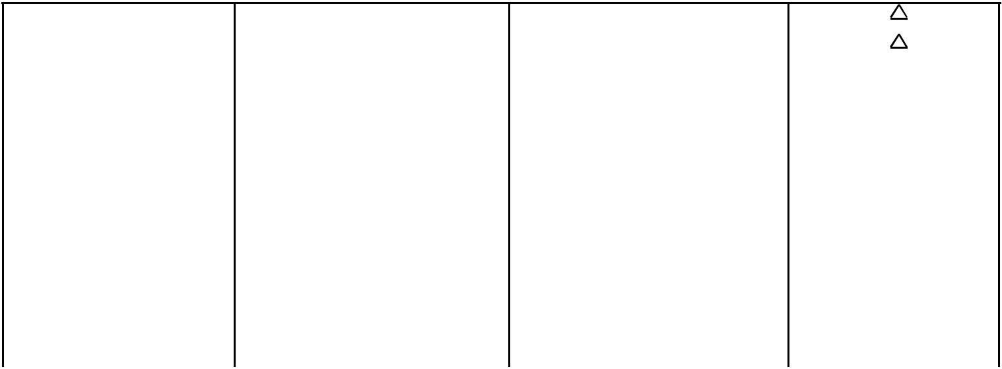

In the table the possibility A is one extreme. The society devotes all the resources to guns and nothing to butter. Suppose the society wants one unit of butter. Since resources are limited and fully and efficiently employed, to produce one unit of butter some of the resources engaged in production of guns have to be transferred to the production of butter. Let the resources worth one unit of gun are enough to produce one unit of butter. This gives us the second possibility with MRT = 1G/IB. Now suppose that the society wants another unit of butter. This requires transfer of more resources from the production of guns. Now we require transfer of resources worth 2 units of guns to produce one more unit of butter. The MRT rises to 2G/IB. MRT rises because now less efficient resources are being transferred. In this way MRT goes on rising.

We can now define MRT in general terms. MRT is the ratio of units of one good sacrificed to produce one more unit of the other good.

|  |  |  |  |  |  |  |
| --- | --- | --- | --- | --- | --- | --- |
| MRT = | Units of one good sacrificed____ |  | = | Guns |  |  |
| More units of the other good produced | | Butter | |  |
|  |  |  |



Or, MRT is the rate at which the units of output of one good are sacrificed to produce on more unit of the other good.

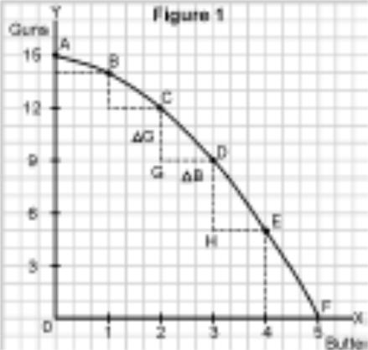

**Production Possibilities Curve**

By converting the schedule into a diagram, we can get the PP curve. Refer to the figure I which is based on the PP schedule. Production of butter is shown on the x-axis and that of guns on the y-axis.

We can measure MRT on the PP curve. For example MRT between the possibilities C and D is equal to CG/GD. Between D and E it is equal to DH/HE, and so on.

Diagrammatically, the slope of the PP curve is a measure of the MRT. Since the slope of a concave curve increases as we move

downwards along the curve, the MRT rises as we move downwards along the curve.

2

**Characteristics**

A typical PP curve has two characteristics:

1. **Downward sloping from left to right**

It implies that in order to produce more units of one good, some units of the other good must be sacrificed (because of limited resources).

1. **Concave to the origin**

A concave downward sloping curve has an increasing slope. The slope is the same as MRT. So, concavity implies increasing MRT, an assumption on which the PP curve is based.

Note that a typical PP curve is taken to be a concave curve because it is based on a more realistic assumption that no resource is equally efficient in production of all goods. So, when resources are transferred from Y to X, more and more units of Y are to be transferred to produce one more unit of X.

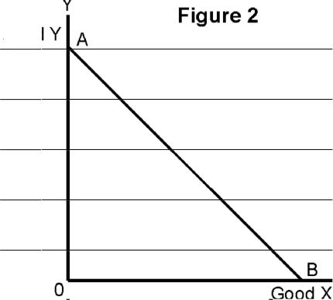

**Can PP curve be a straight line?**

Yes, if we assume that MRT is constant, i.e. slope is constant. When the slope is constant the curve must be a straight line. But when is MRT constant? It is constant if we assume that all the resources are equally efficient in production of all goods.

**Does production take place only on the PP curve?**

Yes and no, both. Yes, if the given resources are fully and efficiently utilized. No, if the resources are underutilized or inefficiently utilized or both. Refer to the figure 3.

On point F, and for that matter on any point on the PP curve AB, the resources are fully and efficiently employed. On point U, below the PP curve or any other point but below the PP curve, the resources are either underutilized or inefficiently utilised or both. Any point below the PP curve thus highlights the problem of unemployment and inefficiency in the economy.

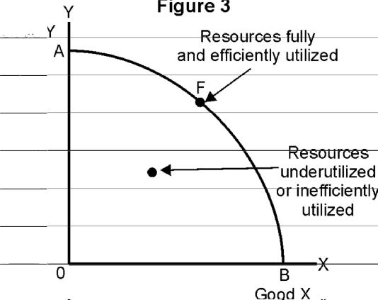

3

**Can the PP curve shift?**

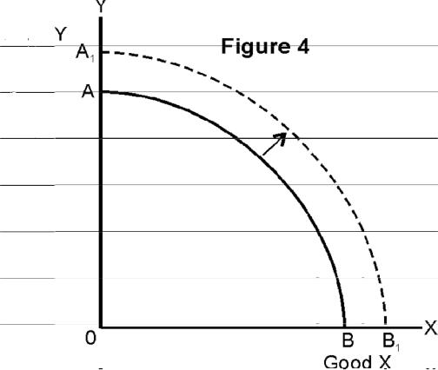

Yes, if resources increase. More labor, more capital goods, better technology, all mean more production of both the goods. A

1. curve is based on the assumption that resources remain unchanged. If resources increase, the assumption is broken, and the existing PP curve is no longer valid. With increased resources there is a new PP curve to the right of the existing PP curve.

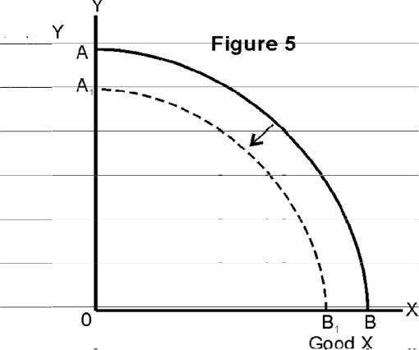

It can also shift, to the left if the resources decrease. It is a rare possibility but sometimes it may happen due to fall in population, due to destruction of capital stock caused by large scale natural calamities, war, etc.

4

**UNIT - II**

**CONSUMER'S EQUILIBRIUM (UTILITY ANALYSIS)**

* **Introduction**

A consumer is one who buys goods and services for satisfaction of wants.

The objective of a consumer is to get maximum satisfaction from spending his given income on various goods and services, given prices.

We start with a simple example. Suppose a consumer wants to buy a commodity. How much of it should he buy? One of the approaches used for getting an answer to this question is 'utility' analysis. Before using this approach, we would like to familiarize ourselves with some basic concepts used in this approach,

* **Concepts**

**Utility**

The term **utility** refers to the want satisfying power of a commodity. Commodity will possess utility only if it satisfies a want. Utility differs from person to person, place to place, and time to time.

**Cardinal Utility :** When utility is expressed in exact units, it is called cardinal utility.

**Ordinal Utility :** When utility is expressed in ranks, it is ordinal utility.

Marginal Utility is the utility derived from the last unit of a commodity purchased. It can also be defined as the addition to the total utility when one more unit of the commodity is consumed.

Total Utility is the sum of the utilities from all the units consumed.

**Law of Diminishing Marginal Utility**

As we consume more units of a commodity, each successive unit consumed gives lesser and lesser satisfaction, that is marginal utility diminishes. It is termed as the Law of Diminishing Marginal Utility.

The following utility schedule will make the Law clear.



|  |  |  |
| --- | --- | --- |
| Units of a commodity | Total Utility (utils) | Marginal Utility (utils) |
|  |  |  |
| 1 | 4 | 4 (=4-0) |
| 2 | 7 | 3 (=7-4) |
| 3 | 9 | 2 (=9-7) |
| 4 | 10 | 1 (=10-9) |
| 5 | 10 | 0 (=10-10) |
| 6 | 9 | -1 (=9-10) |
|  |  |  |

5

Here we observe that as more units are consumed marginal utility declines. This is termed as the **law of diminishing marginal utility.** The law states that with each successive unit consumed theutility from it diminishes.

**How many units of a good to buy**

How many units of a good should a rational consumer decide to buy? The consumer decides by comparing marginal utility (MU) with price (P). The consumer buys so long as MU is greater than, or at least equal to, P, i.e. MU > P. As the consumer buys more MU declines due to the operation of the Law of Diminishing Marginal Utility. So, if initially MU > P, as the cosumer buys more MU declines. The consumer stops when MU becomes equal to price (i.e. MU=P). If the consumer buys more units after MU=P, MU will become less than P. It makes buying more units disadvantageous to the consumer. Let us take on example.

Suppose that price of good the consumer wants to buy is Rs. 3 per unit. Lel the utility be expressed in utils which are measured in rupees. We are given the marginal utility schedule of the consumer.

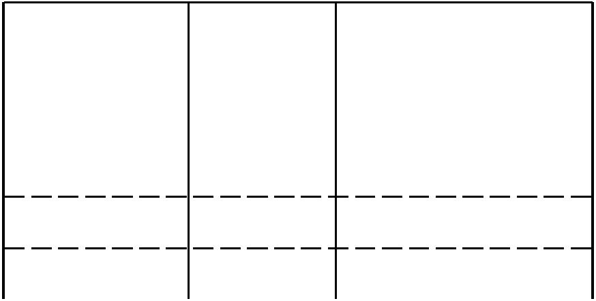

|  |  |  |
| --- | --- | --- |
| Quantity | Price (Rs) | Marginal Utility (Rs) |
|  |  |  |
| 1 | 3 | 8 |
| 2 | 3 | 7 |
| 3 | 3 | 5 |
| 4 | 3 | 3 |
| 5 | 3 | 2 |

When he purchases the first unit, the utility that he gets is 8 utils worth Rs. 8. He has to pay only Rs. 3/- for it. Will he buy the 1st unit? Obviously, yes, because he gets more than what he gives. Similarly, we compare the utility received from other units with the price paid. We find that he will buy 4 units. At the 4th unit, MU equals price. If he buys the 5th unit, he is a looser because the utility that he gets is 2 utils worth Rs.2 and what he has to pay is Rs. 3. Therefore, the consumer will maximize his satisfaction by buying 4 units of this commodity. The condition for maximization of satisfaction when a good is purchased then is:

MU = Price.

1. **EQUILIBRIUM**

A consumer buys not one good but many a goods. For simplification let us assume that the consumer buys only two goods. Let these goods be x and y. Given income and prices, the consumer will be in equilibrium when the following two conditions are satisfied:

1. MU from the last rupee spent on each good is the same.
2. MU declines as more units of a good are consumed. Let us explain these conditions.

6

1. **MU from the last rupee spent on each good is the same.**

Given income, prices and MU schedules, the condition implies that the consumer will get maximum satisfaction by spending his income in such a way that he gets the same utility from the last rupee spent on each good. This is satisfied when

|  |  |  |  |  |  |
| --- | --- | --- | --- | --- | --- |
| MUx |  | = | MUy | = M.U. of a rupee spent on a good. |  |
| Px | | Py |  |
|  |  |  |

We can show that in order to maximise satisfaction this condition must be satisfied. If it is not satisfied what difference will it make. Suppose the two ratios are:

MUx > MUy

Px Py

It means that per rupee MUx is higher than per rupee MUy. It further means that by transferring one rupee from Y to X, the consumer gains more utility than he looses. This prompts the consumer to transfer some expenditure from Y to X. Buying more of X reduces MUx, Px remaining unchanged, MUx/Px, i.e. per rupee MUx, is also reduced. Buying less of Y raises MUy. Py remaining unchanged it raises, per rupee MUy. The change continues till per rupee MUx becomes equal to per rupee MUy. In other words :

|  |  |  |  |  |  |
| --- | --- | --- | --- | --- | --- |
| MUx |  | = | MUy | = per rupee MU |  |
| Px | | Py |  |
|  |  |  |

This condition is also termed as the Law of Equi-Marginal Utility

1. **MU of a good falls as more is consumed of it.**

|  |  |  |  |  |  |
| --- | --- | --- | --- | --- | --- |
| We have seen that when | MU *x* |  | MU*y* | , the consumer buys more of X and less Y. As a result MUx falls |  |
| P *x* |  |  |
|  |  | P*y* | |  |

and MUy rises. This happens due to the operation of the Law of Diminishing Marginal utility. Unless this happens the first equality condition may not be satisfied, and the consumer may end up by buying just one good.

**CONCEPTS OF DEMAND AND DEMAND SCHEDULE**

**Demand** for a good is the quantity of that good which a buyer is willing to buy at a particular price,during a period of time.

**Demand schedule** is a tabular presentation showing the different quantities of a good that buyersof that good are willing to buy at different prices during a given period of time.

|  |  |
| --- | --- |
|  | **Demand schedule of a commodity** |
|  |  |
| Price (Rs. per unit) | Quantity demanded (in units) |
|  |  |
| 50 | 50 |
| 40 | 100 |
| 30 | 150 |
| 20 | 200 |
| 10 | 250 |
|  |  |



7

This schedule indicates that more is purchased as price falls. This inverse relationship between price and quantity demanded, other thing remaining the same is called the **law of demand.**

**LAW OF DEMAND**

The Law of Demand states that, in case of a normal good, there is inverse relation between price of a good and its demand. This relationship can be derived from the consumer’s equilibrium state when the ratio of marginal utility to price in case of all goods consumed is the same.

Suppose consumer consumes only two goods X and Y. Let their respective prices be Px and Py.

Other things remaining unchanged, the consumer will be in equilibrium when:

|  |  |  |  |  |
| --- | --- | --- | --- | --- |
| MUx | | = | MUy |  |
| Px |  | Py |  |
|  |  |

Now, suppose price of good X, i.e. Px, falls. The situation changes. The consumer is no longer in equilibrium. The above equality turns into the following inequality.

|  |  |  |  |  |
| --- | --- | --- | --- | --- |
| MUx | | > | MUy |  |
| Px |  | Py |  |
|  |  |

It means that per rupee marginal utility from consumption of X is greater than from consumption of Y. This induces the consumer to buy more of X and less of Y. The consumer transfers expenditure from Y to X. The consumer now demands more of X. This shows that when price of a good falls, the consumer demands more of that good.

The inverse relation between price and demand can also be shown in another way. We have learnt that a consumer buys a good only upto the point where marginal utility and price are equal, i.e.

MU = Price

Now, suppose price falls, the situation now changes to:

MU > Price

Since marginal utility is greater than price, this induces the consumer to buy more of the good. This shows that when price of a good falls, the consumer demands more of that good.

**RELATIONSHIP BETWEEN TOTAL EXPENDITURE AND PRICE ELASTICITY OF DEMAND** At this stage of learning it is sufficient to know the following about this relationship:

1. When a fall (rise) in the price of a commodity results in increase (decrease) in total expenditure on it, its demand is said to be ‘elastic’.
2. When a fall (rise) in the price of the commodity does not result in any change in total expenditure on it, its demand is said to be ‘unitary elastic’.
3. When a fall (rise) in the price of a commodity results in a fall (rise) in total expenditure on it, its demand is said to be ‘inelastic’.

**FACTORS DETERMINING PRICE ELASTICITY**

Besides ‘nature of the good’ and the ‘availability of substetiles (as in the NCERT book), there can be

8

many other factors determining the degree of response of the consumer to change in price.

Some of these are:

1. Time period of response

Habits change but normally over longer periods. When a consumer is habituated to consuming a good and its price rises, it is very difficult for the consumer to reduce or to give up the consumption of good immediately. However, over a longer time period, the consumer may be able to modify or change habits. As such, longer the time period of reponse, more elastic the demand.

1. Proportion of income spent on the good.

Higher the proportion, higher is the effect on the budget of the consumer. Therefore, higher the proportion of income spent on a good, higher is likely to be the price elasticity of that good. This is why the price elasticity of demand of the low priced goods is lower while those of high priced goods is higher.

9

**Unit III**

**PRODUCER’S BEHAVIOUR AND SUPPLY**

**Meaning of supply**

Supply means the quantity of a commodity which a firm or an industry is willing to produce at a particular price, during period of time.

**Law of supply**

This law states that 'other things remaining the same', an increase in the price of a commodity leads to an increase in its quantity supplied. Thus, more of a commodity is supplied at higher prices than at lower prices.

This law can be explained with the help of a supply schedule and curve.

A supply schedule is a table which shows the quantities of a commodity supplied at various prices during a given time period.

|  |  |  |  |
| --- | --- | --- | --- |
| **Supply Schedule** | | **Supply Curve** |  |
|  |  |
| Price (Rs.) | Supply (Units) |  |  |
|  |  |  |  |

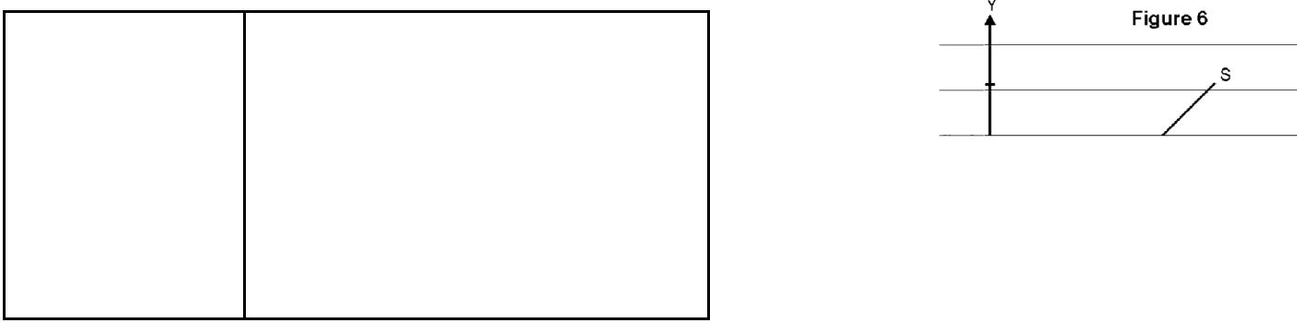

1 100

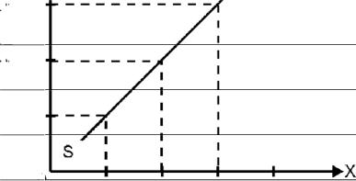

2 200

3 300



As the price increases from Re. 1 to Rs. 3, the supply also rises from 100 units to 300 units, in response to the rising price. What is the basis of the law of supply? Other things remaining the same, an increase in price results in higher profits for the producer. The higher the price of the commodity, the greater are the profits earned by the firms and the greater is the incentive to produce more. Similarly when the price falls, profits decline, resulting in a decrease in quantity supplied of the commodity. Thus the price and quantity supplied of a commodity are directly related, other things remaining the same.

**‘Change in supply’ versus ‘change in quantity supplied’**

(‘shift of supply curve’ versus ‘movement along a supply curve’)

The supply of a commodity depends on its own price and 'other factors' like input prices, technique of production, prices of other goods, goals of the firm, taxes on the commodity etc.

**Movement along a supply curve (change in quantity supplied)**

The law of supply states the effect of a change in the own price of a commodity on its supply, other things remaining constant. The supply curve also carries the same assumption. Thus when other

10

factors influencing supply do not change, and only the own price of the commodity changes, the change in supply takes place along the curve only. This is what **movement along a supply curve** means. A movement from one point to another on the same supply curve is also referred to as

1. **“change in quantity supplied”.**

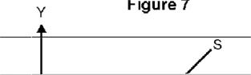

In figure 7, OQ is the quantity supplied at price OP. When the price rises to OP1 the quantity supplied increases to OQ1. Thus there is an upward movement along the supply curve from point A to B. It is **extension of supply.**

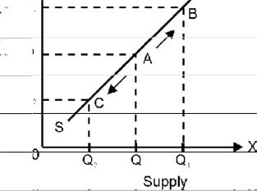

Similarly, when the price of a commodity falls from OP to OP2, there is a decrease in quantity supplied from OQ to OQ2 and thus a downward movement along the supply curve from A to C. It is **contraction of supply.**

Movements along the supply curve are caused by a change in the own price of the good only, other things remaining the same.

**Shifts of the supply curve (change in supply)**

When supply changes due to changes in factors other than the own price of the commodity, it results in a **shift of the supply curve.** This is also referred to as a **“change in** **supply”.**

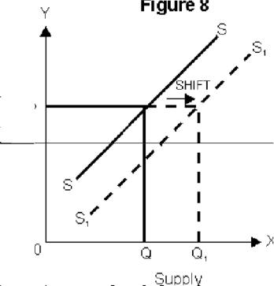

An **‘increase’** in supply means more of the commodity is supplied at same price. As a result the supply curve shifts to the right. Refer to figure 8. When supply ‘increases’ the supply curve shifts to the right. The market is now willing to supply more i.e. OQ, at the same price OP.

An **‘increase’** in supply can take place due to many reasons. For example, if the input prices fall or there is an improvement in technology, it will enable producers to produce and sell more at the same price resulting in a rightward shift of the supply

curve.

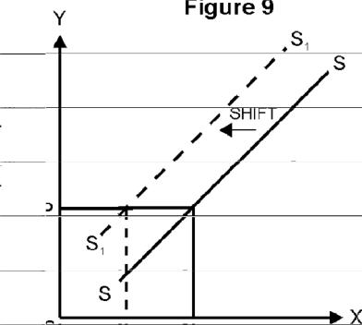

**A ‘decrease’ in supply means** less of the commodity is supplied atthe same price. As a result, the supply curve shifts inwards to the left. In Figure 9 at price OP, previously OQ units were supplied which decreased to OQ1. It means that the market is now willing to supply less at the same price OP.



11

‘Decrease’ in supply of a good can be caused by a change in any one or more of the 'other factors' affecting supply, own price remaining unchanged. For example, if the input prices rise or there is an increase in the prices of other related commodities, the producers supply less at the same price resulting in a leftward shift of the supply curve.



**COST**

**Meaning**

Cost in economics comprises of two elements: explicit cost and implicit cost. Actual money expenditure on inputs is termed as **explicit cost.** Estimated money value of inputs supplied by the owners of production unit, including normal profit, is termed as implicit cost. Main examples are: estimated salary of the owners, estimated interest of own money invested by the owners, estimated rent of the owner’s building, etc. **Normal profit** is that minimum profit which the owners of business must get in the long run for remaining in the current business rather than shift to the next best alternative business.

**Relationship Between MC and AC**

The relationship between marginal cost and average cost is an arithmetic relationship. To understand this relationship let us take a numerical example.

The table A shows the marginal costs, total costs and average costs at different levels of output.

**Table A : Cost Schedule**

|  |  |  |  |
| --- | --- | --- | --- |
| Output | Total cost | Marginal cost | Average cost |
| (Units) | (Rs.) | (Rs.) | (Rs.) |
|  |  |  |  |
| (1) | (2) | (3) | (4) |
| 1 | 60 | 60 | 60 |
| 2 | 110 | 50 | 55 |
| 3 | 162 | 52 | 54 |
| 4 | 216 | 54 | 54 |
| 5 | 275 | 59 | 55 |
|  |  |  |  |

Column 1 shows the level of output.

Column 2 shows the total cost of producing different levels of output.

Column 3 shows the increase in total cost resulting from the production of one more unit of output.

(It is called marginal cost. Thus MCn = TCn - TCn-1, where n and n-1 are levels of output).

|  |  |  |  |
| --- | --- | --- | --- |
| Column 4 shows the average cost at different levels of output (ACn | = | TCn | ) |
|  |  | n | |

12

This table shows that :

1. Average cost falls only when marginal cost is less than average cost. Upto the third unit of output, the marginal cost is less than the average cost and average cost is falling. When 2 units are produced the marginal cost is Rs. 50 which is less than the previous average cost (Rs.60), now average cost falls from Rs. 60 to Rs. 55. When 3 units are produced, the marginal cost is Rs. 52 which is less than the average cost of 2 units (Rs. 55) so once again the average cost falls from Rs. 55 to Rs. 54.
2. Average cost will be constant when marginal cost is equal to average cost. When 4 units are produced, average cost does not change (it is Rs. 54 when 3 units are produced and remains Rs. 54 when 4 units are produced) because marginal cost (Rs. 54) is equal to average cost (Rs. 54).
3. Average cost will rise when marginal cost is greater than average cost. When 5 units are produced average cost rises from Rs. 54 to Rs. 55, because the marginal cost (Rs. 59) is greater than the average cost (Rs. 54).

This relationship between marginal cost and average cost is a generalized relationship and holds good in case of the marginal and average values of any variable, be it revenue or product etc.

In the box a simple proof of the relationship is given : This is for reference only



For Reference only

Suppose AC falls. Then :

TCn < TCn-1

n n-1

Multiplying both sides by n we get,

|  |  |  |  |  |  |  |  |  |  |  |  |  |  |  |
| --- | --- | --- | --- | --- | --- | --- | --- | --- | --- | --- | --- | --- | --- | --- |
| TC | < TC | x | |  | n | | |  |  |  |  |  |  |  |
| n-1 | | | | | | | | | |  |
| n | n-1 |  |  |  |
|  |  |  |  |  |
| TC | < TC | x (1 + | | | | | | | | 1 | | | ) |  |
|  |  |  |  |
| n | n-1 |  |  |  |  |  |  |  |  | n-1 | | | |  |
|  |  |  |  |  |  |  |  |  |  |  |
| TC | < TC |  | + | | TC | | | | n-1 | | |  | |  |
| n-1 | | | | | | | | |  |
| n | n-1 |  |  |  |  |
|  |  |  |  |  |  |
| TC | - TC | < | TC | | |  | n-1 | | | |  | | |  |
|  | | |  |  | | | |  |
| n | n-1 |  |  |  | n-1 | | | | | | | | |  |
|  |  |  |  |  |  |

Since the left hand side is MC, and the right hand side is AC, it proves that

MC < AC

Thus a fall in average cost means marginal cost is less than average cost. It can similarly be proved that a rise in average cost means, marginal cost is greater than average cost and a constant average cost means marginal cost is equal to average cost.

The relationship between marginal cost and average variable cost is similar to the relationship between marginal cost and average cost because marginal cost is not affected by fixed cost.

13

(For proof see box which is for reference only)

MCn = TCn - TCn-1

* [TFCn + TVCn] - [TFCn-1 + TVCn-1] Since TFCn and TFCn are equal

MCn = TVCn - TVCn-1

**LAW OF VARIABLE PROPORTIONS IN TERMS OF TP AND MP CURVES.**

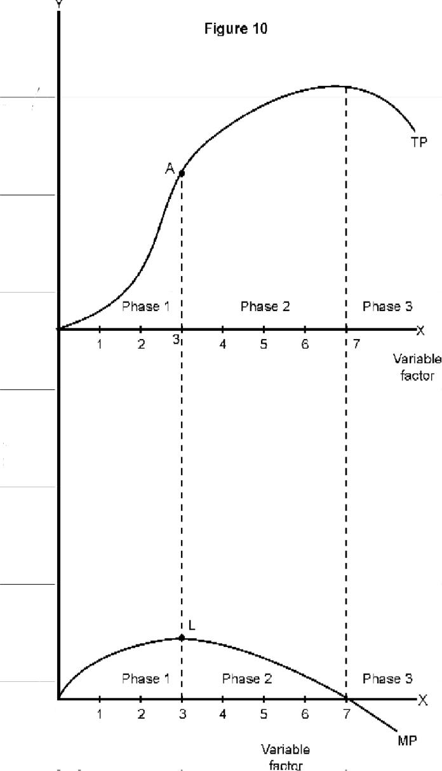

1. **In terms of TP**

As more and more units of variable factor are employed with fixed factor, total product initially increases at an increasing rate then increases at decreasing rate and ultimately starts decreasing. On the TP curve in the diagram, upto point A, TP is increasing at an increasing rate. If more than 3 units of variable factor are employed, total product still increases till 7units are employed but this increase is at a diminishing rate. If beyond 7 units of variable factor are employed then TP starts

14

falling. These are the three respective phases of the law. (Note that TP is convex in phase 1; concave in phase 2; and downward sloping in phase 3. This is how we can identify the three phases.)

1. **In terms of MP**

MP increases upto 3 units. This is phase 1. MP falls after 3 units but is positive upto 7 units. This is phase 2. MP continues to fall but is negative after 7 units. This is phase 3. Therefore, in phase 1 the MP curve is upward sloping; downward sloping but above the X-axis in phase 2; and downward sloping but below the X-axis in phase 3.

**PRODUCER’S EQUILIBRIUM: MC=MR APPROACH**

**INTRODUCTION**

Producer’s equilibrium refers to the level of output of a commodity which gives the maximum profit to the producer of that commodity. Profit equals total revenue less total cost. Therefore, the output level at which ‘total revenue less total cost’ is maximum is called the equilibrium output level.

**MC = MR approach**

MC = MR approach is the way of identifying producer’s equilibrium. The two conditions of MC = MR approach are:

1. MC = MR
2. MC is greater than MR after the MC = MR output level.

Let us explain these conditions.

1. **MC = MR**

When one more unit of output is produced, MR is the benefit in terms of more revenue and MC is the cost to the producer. Clearly, so long as benefit is greater than the cost, or MR is greater than MC, it is profitable to produce more. Therefore, so long as MR is greater than MC, the maximum profit level, or the equilibrium level is not reached. The equilibrium is not achieved because it is possible to add to profits by producing more.

The producer is also not in equilibrium when MR is less than MC because benefit is less than the cost. By producing less the producer can add to his profits.

When MC is equal to MR, the benefit is equal to cost, the producer is in equilibrium subject to that MC becomes greater than MR beyond this level of output. When MC equals MR(subject to the sup-porting condition) the producer’s profit would be less if he produces output more than or less than the ‘MC = MR’ output as explained above. Therefore, for equilibrium to reach it is a necessary condition (but not sufficient) that MC equals MR.

1. **MC is greater than MR after MC = MR output level**

‘MC = MR’ is a necessary condition but not sufficient enough to ensure equilibrium. It is because the producer may face more than one MC =MR outputs. But out of these only that output beyond which

15

MC becomes greater than MR is the equilibrium output. It is because if MC is greater than MR, producing beyond MC = MR output will reduce profits. And when it is no longer possible to add to profits the maximum profit level is reached. On the other hand, if MC is less than MR beyond the MC

* MR output, it is possible to add to profits by producing more. Therefore this MC = MR level is not the equilibrium level.



For a producer to be in equilibrium it is necessary that MC equals MR as well MC becomes greater than MR if more output is produced.

**Illustrations and Graphic Presentation**

**Illustration I**

The following illustration relates to the market which allows the producer to sell any quantity he can at the prevailing market price.

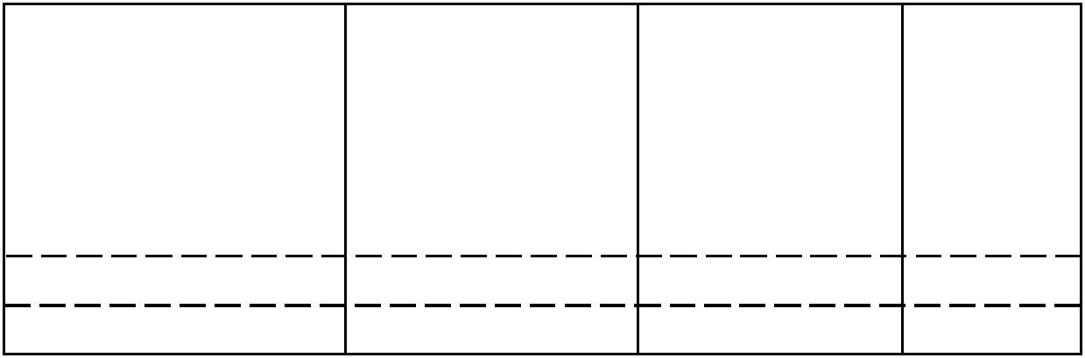

|  |  |  |  |  |  |  |
| --- | --- | --- | --- | --- | --- | --- |
| Price | output | TR | TC | MR | MC | Profits |
| (Rs. perunit) | (units) | (Rs.) | (Rs.) | (Rs.) | (Rs.) |  |
|  |  |  |  |  |  |  |
| 8 | 1 | 8 | 8 | 8 | 8 | 0 |
| 8 | 2 | 16 | 15 | 8 | 7 | 1 |
| 8 | 3 | 24 | 20 | 8 | 5 | 4 |
| 8 | 4 | 32 | 28 | 8 | 8 | 4 |
| 8 | 5 | 40 | 38 | 8 | 10 | 2 |

Note that in the above illustration MC = MR condition is satisfied both at output level one unit and the output level 4 units. But the second condition – MC becomes greater than MR – is satisfied only at 4 units of output. Therefore equilibrium output level is 4 units.

**Graphics Presentation**

When a producer is free to sell any quantity at a given price, the MR curve is perfectly elastic and is parallel to the X-axis. A typical MC curve is a U – Shape curve.

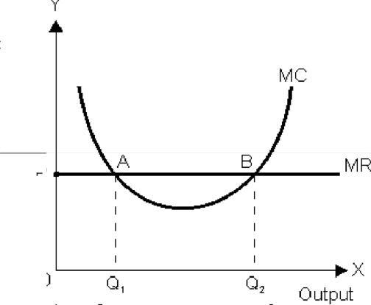

Graphically, the two conditions of equilibrium become:

1. MC curve intersects MR curve.
2. MC curve intersects MR curve from below.

16

Note that the first condition (MC = MR) is satisfied both at A and B. But the second condition – MC Curve intersects MR curve from below – is satisfied only at B. After B, MC becomes greater than MR. Then, the equilibrium output level is OQ2.

**Illustration 2**

This illustration relates to a market in which a producer can sell more only by lowering the price.

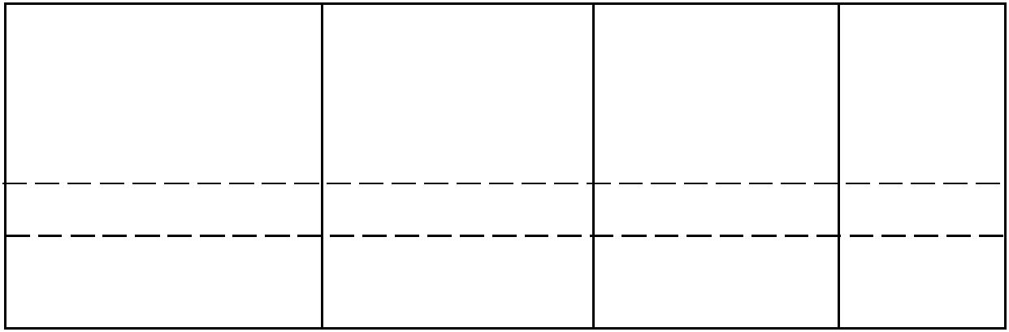

|  |  |  |  |  |  |  |
| --- | --- | --- | --- | --- | --- | --- |
| Price | output | TR | TC | MR | MC | Profits |
| (Rs. perunit) | (units) | (Rs.) | (Rs.) | (Rs.) | (Rs.) |  |
|  |  |  |  |  |  |  |
| 8 | 1 | 8 | 5 | 8 | 5 | 3 |
| 7 | 2 | 14 | 8 | 6 | 3 | 6 |
| 6 | 3 | 18 | 12 | 4 | 4 | 6 |
| 5 | 4 | 20 | 17 | 2 | 5 | 3 |
| 4 | 5 | 20 | 23 | 0 | 6 | -3 |

In this illustration the two conditions of equilibrium are satisfied at 3 units of output. MC equals MR and MC is greater than MR when more output is produced. The producer is in equilibrium when he produces 3 units of output.

**Graphic presentation**

When a producer can sell more only by lowering the price, the MR curve is downward sloping. The typical MC curve is U-shaped.

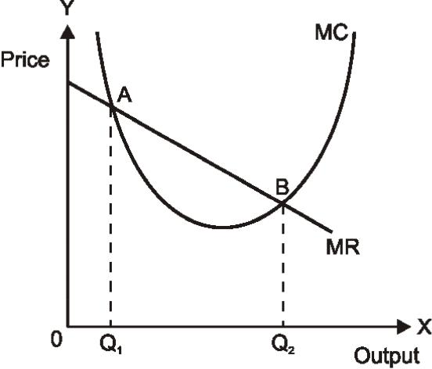

Note that MC = MR condition is satisfied at both A and B. But the second condition – MC is greater than MR or MC curve cuts MR from below – is satisfied only at B. So, the equilibrium level of output in OQ2.

17

**UNIT 4**

**EQUILIBRIUM PRICE UNDER PERFECT COMPETITION**

**Meaning of equilibrium**

Equilibrium, in general terms. implies (a) a balance between the opposite forces and (b) a state of rest or a situation that has a tendency to persist. Let us take examples to show the application of these meanings in microeconomics.

Let us take a market situation in which buyers and sellers are negotiating to buy and sell a good. Both have different prices to offer. But the good will be sold only when both agree to a common price and a common quantity at that price. If both agree, a market equilibrium is said to emerge. Note that buyers and sellers have opposite interests. The buyers will like to pay as low a price as possible. The sellers will like to charge as high a price as possible. Agreement on a common price and quantity creates a balance between the two opposite interests. This equilibrium price and quantity has a tendency to persist.

**Equilibrium price**

Equilibrium price is the price at which the sellers of a good are willing to sell the same quantity which buyers of that good are willing to buy. We can explain this meaning with the help of market demand and supply schedule of a good, given below :

|  |  |  |  |
| --- | --- | --- | --- |
| Price per unit | Market demand | Market supply | Equilibrium |
| (Rs.) | (units) | (units) |  |
|  |  |  |  |
| 1 | 1000 | 200 | Excess demand |
| 2 | 800 | 400 | Excess demand |
| **3** | **600** | **600** | **Market Equilibrium** |
| 4 | 400 | 800 | Excess supply |
| 5 | 200 | 1000 | Excess supply |



Refer to the schedule. The market equilibrium is established at a price of Rs. 3 per unit, because at this price both the market demand and market supply are equal. This is the price which has a tendency to persist.

**Why is not any other price an equilibrium price?**

Take, for example, a price less than the equilibrium price. Suppose it is Rs. 2 per unit. At this price market demand is greater than market supply. It is called an **excess demand** situation. But this price cannot persist. It will change. Why?

It is because the buyers will not be able to buy all what they want to buy. The pressure of excess demand will push the market price up. This will have two effects. Supply will go up because the producers are willing to supply more at a higher price. Demand will go down because the buyers are

18

willing to buy less at a higher price. In fact, this is what is required to restore equilibrium. The tendency of supply going up and demand going down will continue till market supply becomes equal to market supply once again and the excess demand becomes zero. This is achieved at Rs. 3 per unit. The equilibrium is restored.

Let us now take a price higher than the equilibrium price. Suppose it is Rs. 4 per unit. At this price now the market supply is greater than market demand. It is called an **excess supply** situation. Even this price cannot persist. It is because the sellers will not be able to sell all what they want to sell. The excess supply pressure will push the price downwards. This will have two effects. Supply will go down and demand will go up. The tendency will continue till market demand becomes equal to market supply once again, and the price settles at Rs. 3 per unit.

To sum up, the equilibrium price is the price at which market demand equals market supply. This price has a tendency to persist. If at a price the market demand is not equal to market supply there will be either excess demand or excess supply and the price will have tendency to change until it settles once again at a point where market demand equals market supply.

**Graphic Presentation**

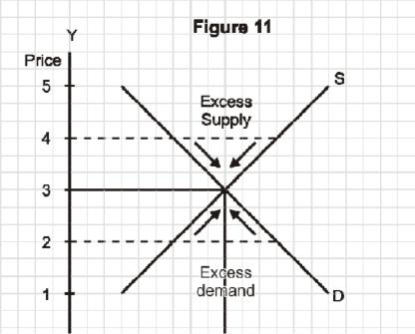

The equilibrium is at E the intersection of supply and demand curves representing the two schedules given above. The equilibrium price is Rs. 3 and equilibrium quantity 600 units. The price higher than Rs. 3, creates excess supply and ultimately returns to Rs. 3 on account of the effects explained above. The arrows indicate the tendencies. The price below the equilibrium price creates excess demand and has a tendency to return to Rs. 3 per unit on account of the effects explained above and indicated by the arrows.

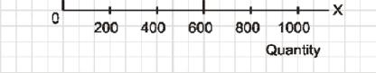

**Can the equilibrium price change?**

Yes, when demand or supply or both increase or decrease. 'Increase', as you know, means rise in demand or supply due to factors other than the own price of the good. Similarly the term 'decrease' is defined. Graphically, it means shift of demand curve, or supply curve or both. You are familiar with these terms. You are expected to study the chain effects of shifts in demand and supply on equilibrium price and quantity.

**FEATURES OF PERFECT COMPETITION**

**Introduction**

Perfect competition is a state of a market. Anything which facilitates contact between buyers and sellers constitutes a market. It may be a face to face meeting at some place or simply verbal negotiations through telephone, internet, etc.

Conventionally, in microeconmoics the markets are classified into these states: perfect competiton, monopoly, monopolistic competition and oligopoly. There are many criteria of classification, the number of sellers, similarity of products, availability of information, mobility of firms and the inputs engaged in the firm, etc. Whatever the criteria the end result is reflected in one thing : how much influence an individual seller, on his own, is able to exercise on the market. Lower the influence more

19

the competitive nature of the market it indicates. If the influence of an individual seller is zero, or virtually zero, the market is said to be perfectly competitive.

**Meaning**

Perfect competition can be defined either in terms of its characteristic features, or in terms of the unique end result of these characteristics. Unique in the sense that it is specific to a perfectly competitive market. In terms of its features, a perfectly competitive is a market where there are large number of buyers and sellers, the firms produce homogeneous products, the buyers and sellers have perfect knowledge and the firms are free to enter or make an exit in and out of industry. In terms of the end result of these features which is unique to this market, **a perfectly competitive market is one in** **which an individual firm cannot influence the prevailing market price of the product on its own.**

**Features and their implications**

A perfectly competitive market has the following features:

1. **Large number of sellers and buyers**

Note that 'large number' is not a specifically defined number. However, it has a specific implication. Let us talk about the large number of sellers first. The words 'large number' imply that the number of sellers is large enough to render a single seller's share in total market supply of the product insignificant. It has a further implication. Insignificant share means that if only one individual firm reduces or raises its own supply, the prevailing market price remains unaffected. The prevailing market price is the one which was set through the interaction of market demand and market supply forces, for which all the sellers and all the buyers together are responsible. One single seller has no option but to sell what it produces at this market determined price. This position of an individual firm in the total market is referred to as **price taker.** This is a unique feature of a perfectly competitive market.

Similarly, the 'large number' of buyers also has the same implication. A single buyer's share in total market demand is so insignificant that the buyer cannot influence the market price on his own by changing his demand. This makes a single buyer also a price taker.

To sum up, the feature 'large number' indicates ineffectiveness of a single seller or a single buyer in influencing the prevailing market price on its own, rendering him simply a price taker.

1. **The products of all the firms in the industry are homogenous**

It means that the buyers treat the products of all the firms in the industry as homogenous. The products produced by the firms are identical, or treated as identical, or perfectly standardized. The buyers do not distinguish the output of one firm from that of the other.

The implication of this feature is that since the buyers treat the products as identical they are not ready to pay a different price for the product of any one firm. They will pay the same price for the products of all the firms in the industry. On the other hand, any attempt by a firm to sell its product at a higher price will fail.

20

To sum up, the 'homogenous products' feature ensures a uniform price for the products of all the firms in the industry.

1. **Perfect knowledge about markets for outputs and inputs.**

The firms have all the knowledge about the product market and the input markets. Buyers also have perfect knowledge about the product market.

Let us take the product market first. The implication of perfect knowledge about the product market is that any attempt by any firms to charge a price higher than the prevailing uniform price will fail. The buyers will not pay because they have perfect knowledge. There is no ignorance factor operating in the market. The sellers do not charge a lower price due to ignorance. The buyers do not pay a higher price due to ignorance. A uniform price prevails in the market.

As regards the knowledge about the input markets, the implicit assumption is that each firm has an equal access to the technology and the inputs used in the technology. No firm has any cost advantage. Cost structure of each firm is the same. All the firms have a uniform cost structure.

Since there is uniform price and uniform cost in case of all firms, and since profits equal cost less price, all the firms earn uniform profits.

1. **Freedom to firms to enter or to leave the industry in the long run**

Freedom of entry means that there are no artificial barriers and natural barriers in the way of a new firm wishing to enter into industry. The artificial barriers may take the form of patent rights, legal restrictions, etc. The natural barrier may take the form of huge capital expenditure required to start a new firm, which the firm wishing to enter is not able to arrange.

Freedom of exit means no barriers in the way of a firm deciding to leave the industry. Government rules, labour laws, loss of huge fixed capital etc. do not come in the way.

The freedom of entry and exit of firms has an important implication. This ensures that no firm can earn above normal profits in the long run. Each firm earns just the normal profits, i.e. minimum necessary to carry on business. In Microeconomics, normal profits is treated as an opportunity cost, and therefore, counted in calculation of total cost. Since profit equals total revenue minus total cost, normal profit means zero economic profit. Why? Let us explain.

Suppose the existing firms are earning above normal profits, i.e. positive economic profits. Attracted by the positive profits, the new firms enter the industry. The industry's output, i.e. market supply, goes up. The price comes down. New firms continue to enter and the price continues to fall till economic profits are reduced to zero.

Now suppose the existing firms are incurring losses. The firms start leaving. The industry's output starts falling, price starts going up, and all this continues till losses are wiped out. The remaining firms in the industry then once again earn just the normal profits.

Only zero economic profit in the long run is the basic outcome of a perfectly competitive market.

21

**Average Revenue and marginal revenue curves of a perfectly competitive firm**

The forces of market supply (i.e. supply by industry) and market demand (demand by all the buyers) determine the market price. The firm, being a price taker, adopts this price and is free to sell any quantity it likes at this price. The price taker feature determines the shape of the firms AR and MR curves. Refer to the figure -12 b

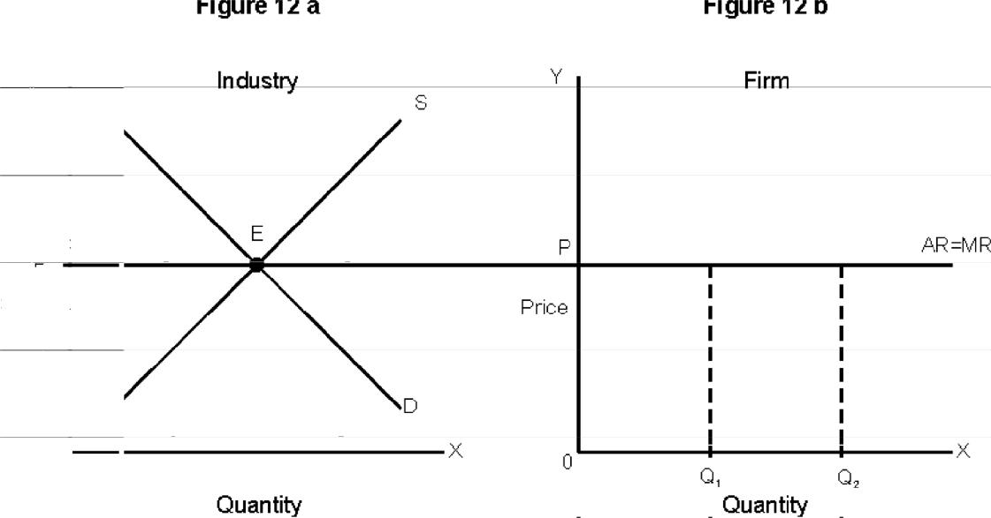

The figure 12a shows the intersection of demand and supply curves at E determining the price OP. The figure 12b shows the adoption of price by the price taker firms which are free to sell any quantity, at this price. This makes the AR curve perfectly elastic and thus parallel to the X-axis. As per the average marginal relationship, when AR is constant, MR must be equal to AR. Therefore, AR curve is also the MR curve of the firm.

**OLIGOPOLY**

**MEANING**

Oligopoly is a market situation in which an industry has only a few firms (or few large firms producing most of its output) mutually dependent for taking decisions about price and output. The two features of this definition – few firms and interdependence between firms – are explained in a section below.

If in an oligopoly market, the firms produce homogeneous products, it is called **perfect oligopoly.** If the firms produce differentiated products, it is called **imperfect oligopoly.**

If in an oligopoly market, the firms compete with each other, it is called a **non-collusive, or non-cooperative, oligopoly.** If the firms cooperate with each other in determining price or output orboth, it is called **collusive oligopoly,** or **cooperative oligopoly.**

When there are only two firms producing a product, it is called **duopoly.** It is a special case of oligopoly.

**FEATURES**

1. **Few firms**

Few firms mean either only a few firms in number or a few big firms producing most of the output of the industry. The exact number of firms is not defined. The word ‘few’ signifies that the number of firms is manageable enough to make a guess of the likely reactions of rivals by a firm.

22

1. **Firms are interdependent in taking price and output decisions.**

When there is only a limited number of firms, it is likely that rivals have some knowledge as to how these firms operate. It one firm does something about the price and quantity of the product it produces, the rivals are likely to take quick note of it and react by changing their own price and output plans. Therefore the given firm, expecting reactions from its rivals, takes into account such possible reactions before taking any decision about the price and output of the product it pro-duces. It makes each firm dependent on other firms in the industry.

1. **Barriers to the entry of firms.**

The main reason why the number of firms is small is that there are barriers which prevent entry of firms into industry. Patents, large capital, control over the crucial raw materials etc, prevent new firms from entering into industry. Only those who are able to cross these barriers are able to enter.

1. **Non-price competition**

Firms try to avoid price competition for the fear of price war. They use other methods like adver-tising, better services to customers, etc to compete with each other.

23